


DTLS Guide
Security Setup
V 6.1
June 2026

Table of Contents
1 Purpose 3
2 Fiori Configuration 3
2.1 Custom Catalogs 3
2.1.1 Creating a New Catalog 3
2.1.2 Custom Tiles and Target Mapping 6
2.1.2.1 Tile 9
2.1.2.2 Target Mapping 9
2.2 Custom Groups 10
2.2.1 Creating Group 12
2.2.2 Assigning Applications 12
2.3 Custom Spaces and Pages 13
2.3.1 Create Custom Space 13
2.3.2 Configuring Custom Page 15
3 Security Role Configuration 19
3.1 Authorization Object: ZDTLS_S 19
3.2 Creating DTLS Roles 21
3.2.1 Creating a DTLS Fiori End User Role 21
3.2.2 Creating a DTLS Maintain Role 29
3.2.3 Creating a DTLS Display Role 33
3.2.3.1 Adding Comment Functionality to a Display User 1
3.3 Workflow Functionality 1
3.3.1 Workflow Configuration Role 1
3.3.2 Workflow Notification Role 1
3.3.3 Workflow Approver Role 1
3.3.4 Advanced Configuration 1
4 Common Issues and Troubleshooting Steps 1
4.1 - PFCG Custom ZDTLS TADIR Service does not show up in PFCG 1
5 Document References 1
6 Revision History 1

Purpose
The purpose of this document is to outline the necessary steps/guidelines for creating security roles with the correct authorizations relevant to DTLS. Also, this document will cover creating Fiori groups and catalogs for the purposes of assigning them to DTLS roles.

Fiori Configuration
Fiori configuration consists of creating the necessary Catalogs, Groups, Spaces, and Pages required for providing the end users with the ability to access the Applications (Tiles) in the Fiori Launchpad.
It’s important to note that, depending on your S/4HANA version, there may be a difference in how the Tiles are organized and presented to the end users. Spaces and Pages were introduced in S/4HANA 2020 which requires the configuration of Catalogs, Spaces, and Pages. Prior to S/4HANA 2020 the Fiori Launchpad was configured using Catalogs and Groups.
There is also a consideration as to which method you are using currently (Catalogs and Groups or Catalogs and Spaces/Pages) which will determine the configuration steps you will follow below. Please determine the method that you are currently using and follow the necessary steps.
Prerequisites:
- Fiori Gateway Activated for the system
- Workbench Transport created via transaction SE10
- Custom Package created via transaction SE80 (recommend package: ZDTLS)
- Necessary authorizations defined for Fiori Administration
- End users already have the required Fiori Baseline access

Custom Catalogs
To assign the different applications to the end users a custom Catalog needs to be created with the custom Tile configuration for each application. Note that one or more Catalog’s may need to be created.

The Catalog defines the applications that the end users can access in their Fiori Launchpad. Segregating apps out into different roles requires different Catalogs as an end user will see all the apps that are included in the Catalog(s) assigned to their role.

Creating a New Catalog
The Fiori Launchpad Configuration application can be accessed through the SAP GUI using the following transaction: /UI2/FLPD_CONF
Alternatively, the Fiori Launchpad Configuration can be accessed through this URL: https://<host>.<domain>:<port>/sap/bc/ui5_ui5/sap/arsrvc_upb_admn/main.html?sap-client=<Client>?scope=CONF
Steps:
- Launch the Fiori Configuration Application, making sure the top right says ‘Client: ALL’.
- Click on the Gear Icon to choose a Transport and assign a Package for the creation of the new Catalog(s) and Tile information:
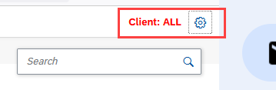
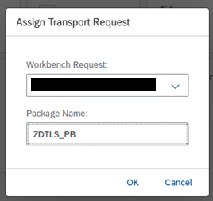

- After a Transport and Package have been chosen then we need to create a new Catalog. Click on the ‘+’ icon on the bottom left to create a new Catalog:
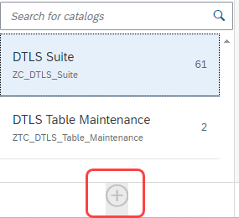
- Recommended Catalog Name: DTLS Suite
- Recommended Catalog ID: ZC_DTLS_Suite (Note: follow your corporate naming conventions)
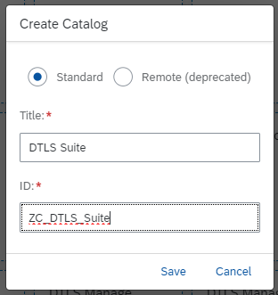
- Now proceed to the next section to create the custom Tiles in this new Catalog.

Custom Tiles and Target Mapping
Each application will require a static ‘Tile’ and ‘Target Mapping’ configuration using the Technical Details shown on the next page.

App Title | Semantic Object | Action | Icon | SAPUI5 Component | HTML5 App Name | Parameters
Process History | dtls_process_builder_v2 | display | sap-icon://wrench | ca.dtls.process_builder_v2 | zdtls_pb_v2 | app-mode=history  (Note: This entry does not require a target mapping, only a tile)
Relationship Explorer | relationship_explorer | display | sap-icon://FioriInAppIcons/Parallel Sequence | ca.dtls.relationshipexplorer | zdtls_rel_exp
Process Builder | dtls_process_builder_v2 | display | sap-icon://wrench | ca.dtls.process_builder_v2 | zdtls_pb_v2
Handover to Manufacturing | handover_to_maufacturing | display | sap-icon://inventory | ca.dtls.handover-to-manufacturing | zdtlsh2m
DTLS Manage Material Master Data | zDTLSMaterialMaster | maintain | sap-icon://Fiori2/F0328 | ca.dtls.dtls-material-master | ZDTLSMATERIALS
DTLS Manage Flavour Classes | DTLSGROUP | display | sap-icon://bbyd-active-sales | ca.dtls.group | zdtls_group
DTLS Manage Flavour Characteristics | DTLSCharacteristics | display | sap-icon://course-book | ca.dtls.characteristic | zdtls_char
DTLS Manage Equipment Classes | dtls_equipment | display | sap-icon://add-equipment | ca.dtls.equipment | zdtls_equip
DTLS Manage Process Workflow Rules | dtls_workflow | display | sap-icon://validate | ca.dtls.workflow | zdtlsworkflow
DTLS Manage Process Areas | zdtls_processarea | display | sap-icon://Fiori3/F0537 | ca.dtls.process-areas | zdtls_parea
DTLS Thread Execution Analyzer | zdtls_tea | display | sap-icon://line-chart | ca.dtls.thread_execution_analyzer | zdtls_tea
DTLS Manage Material Classes | dtls_mat_class | display | sap-icon://machine | ca.dtls.material-classes | zdtls_mat_class
DTLS Manage Risk Types | dtls_risk | maintain | sap-icon://flag-2 | ca.dtls.risk | zdtls_risk
DTLS Manage Step Templates | ZDTLS_STEP_TEM | display | sap-icon://Fiori2/F0006 | ca.dtls.steptemplates | zdtls_step_tem
DTLS Site Model | zdtls_site | maintain | sap-icon://building | ca.dtls.site | zdtls_site
DTLS Reporting Layers | dtls_layer | maintain | sap-icon://BusinessSuiteInAppSymbols/icon-collected-change-request | ca.dtls.reportinglayers | ZDTLS_LAYER
DTLS Product App | dtls_prod | maintain | sap-icon://pharmacy | ca.dtls.product | ZDTLS_PROD
DTLS My Tasks | DTLSMyTasks | maintain | sap-icon://Fiori4/F0539 | ca.dtls.mytasks | zdtls_mytasks
DTLS Manage Modalities | dtls_prdfm | maintain | sap-icon://BusinessSuiteInAppSymbols/icon-products | ca.dtls.productfamily | ZDTLS_PDFAM
DTLS Manage Configuration Rules | dtls_config | maintain | sap-icon://information | ca.dtls.configapp | zdtls_cfg
DTLS Operation Templates | ZDTLS_OP_TEM | display | sap-icon://Fiori2/F0006 | ca.dtls.operationtemplates | zdtls_op_tem
DTLS Manage Types | dtls_types | maintain | sap-icon://multiselect-none | ca.dtls.manage-types | zdtls_types
DTLS Capabilities | dtls_cap | maintain | sap-icon://FioriInAppIcons/Hierarchal Tree | ca.dtls.capabilities | zdtls_cap
DTLS Facility Fit | dtls_ffit | display | sap-icon://BusinessSuiteInAppSymbols/icon-class | ca.dtls.facility-fit | zdtls_ffit

Tile
Create each custom tile as per the following (using the information from the table above):
- Title = App Title
- Semantic Object = Semantic Object
- Action = Action (action must be in lowercase)
- Keyword = ‘DTLS’
- Icon = Icon
- Parameters = leave blank
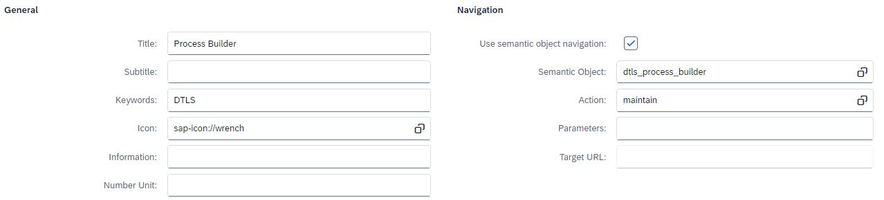

Target Mapping
Create each custom Target Mapping as per the following (using the related information from the table above):
- Semantic Object = Semantic Object
- Action = Action
- Application Type = ‘SAPUI5 Fiori App’
- Title = App Title
- URL = /sap/bc/ui5_ui5/sap/<HTML5 App Name>
- ID = SAPUI5 Component
- Information = leave blank
- Device Types = Desktop and Tablet
- Parameters = leave blank
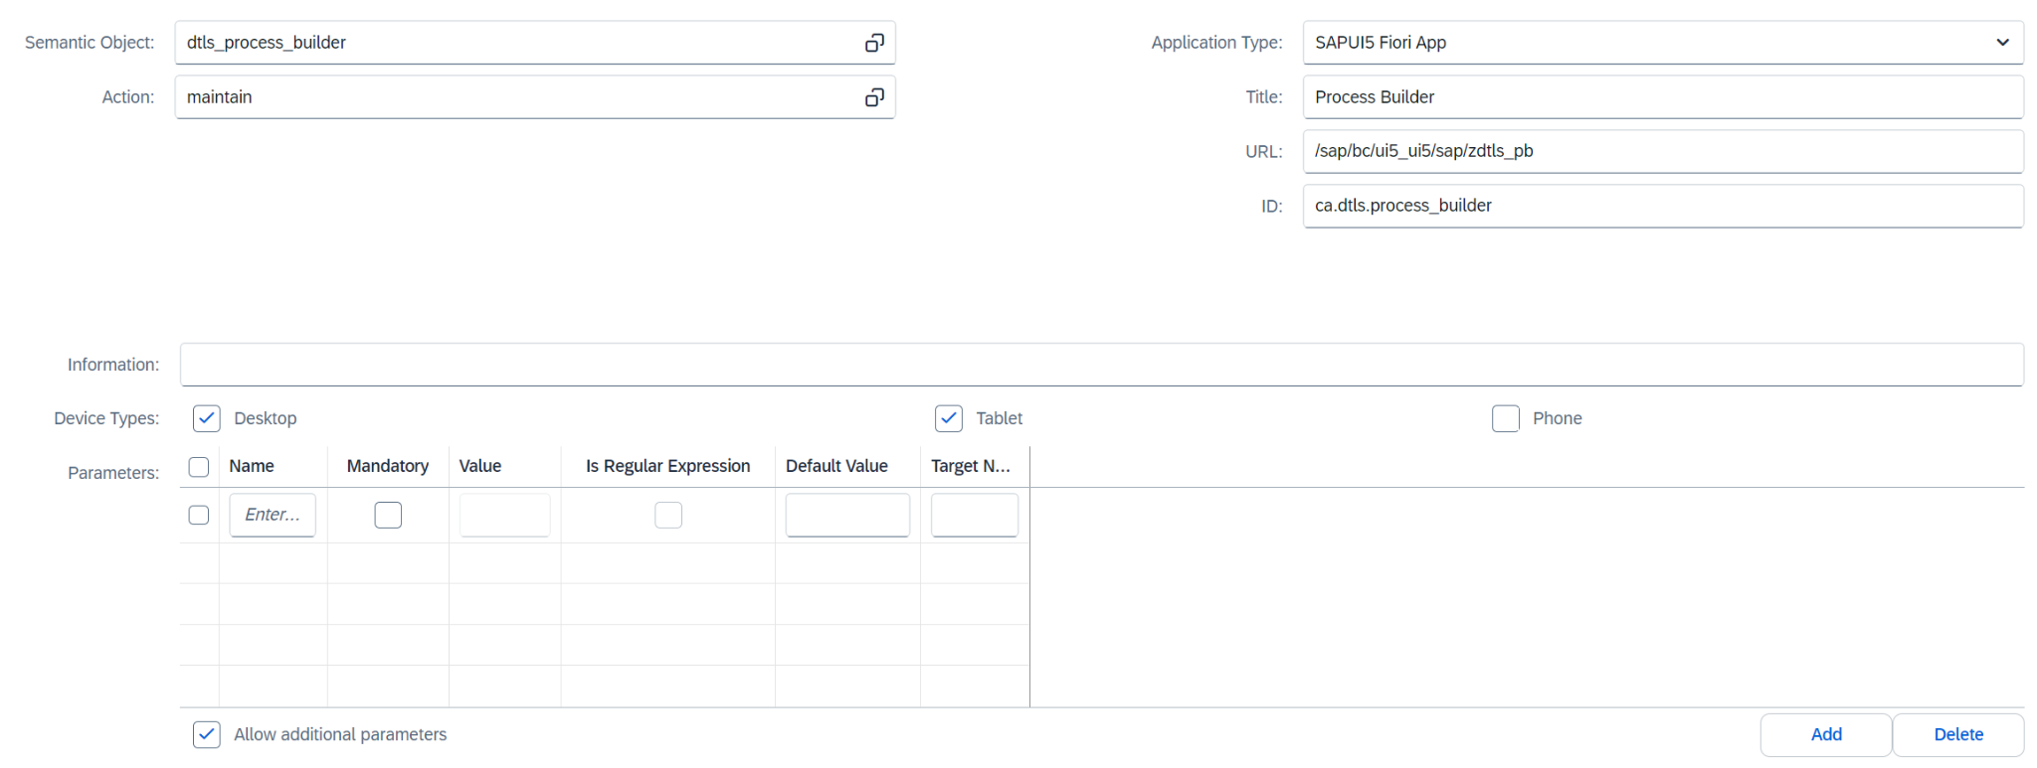

Custom Groups
Determine if you are using Catalogs and Groups or Catalogs and Spaces/Pages. If you are not using Groups then please refer to the ‘Custom Spaces and Pages’ section below.
The Groups determine the section under which the individual applications will be displayed in the Fiori Launchpad.
Use the following table as an example of how individual Groups can be created to display them in the corresponding Groups in the Fiori Launchpad:
Group Name | Lifecycle Management | Configuration | Material Management | Analytics and BI
Group ID | ZG_DTLS_Lifecycle_Mgmt | ZG_DTLS_Configuration | ZG_DTLS_Materials | ZG_DTLS_Analytics
Application
Process Builder | X
Process History | X
Relationship Explorer | X
Handover to Manufacturing | X
Facility Fit
Manage Equipment Classes |  | X
Manage Flavour Class (Group) |  | X
Manage Flavour Characteristic |  | X
Manage Types |  | X
Manage Configuration Rules |  | X
Manage Material Master Data |  |  | X
Manage Material Classes |  |  | X
Manage Process Areas |  | X
Manage Risk Types |  | X
Manage Step Templates |  | X
Manage Operation Templates |  | X
Manage Process Workflow Rules |  | X
My Tasks | X
Thread Execution Analyzer |  |  |  | X
Site Model |  | X
Manage Reporting Layers |  | X
Products |  | X
Manage Modalities |  | X
Manage Capabilities |  | X

Creating Group
- Enter the Title and ID from the table above for each of the required Groups.
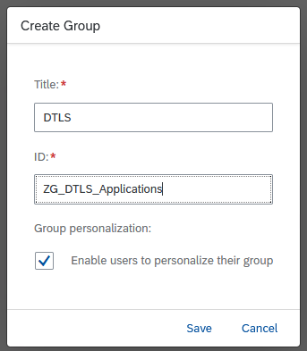

Assigning Applications
- Assign the required applications for each group by selecting them from the ZC_DTLS_Suite Catalog created in the previous steps.
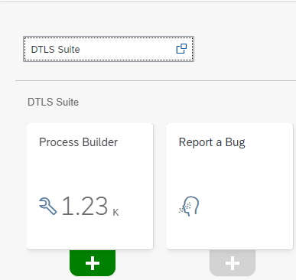

Custom Spaces and Pages
Determine if you are using Catalogs and Groups or Catalogs and Spaces/Pages. If you are not using Spaces and Pages then please refer to the ‘Custom Groups’ section above.
Spaces and Pages provide an additional level of navigation to the Fiori Launchpad. Spaces will be displayed in the top level navigation in the Fiori Launchpad. Pages are then displayed under the assigned Spaces and are organized by Page Sections.
Additional Prerequisites:
- Customizing Transport created via transaction SE10
- Necessary authorizations defined for Fiori Space and Page Administration
- Activation of ICF and OData services for Fiori apps F4834 (Manage Launchpad Spaces) and F4512 (Manage Launchpad Pages)
For DTLS we suggest creating one Space and one Page with a number of different Page Sections.

Create Custom Space
- The Fiori Spaces and Pages Configuration applications can be accessed through the SAP GUI using the following transaction: /UI2/FLP
Alternatively, the Fiori Launchpad can be accessed through this URL: https://<host>.<domain>:<port>/sap/bc/ui2/flp
- Navigate to the ‘Fiori Launchpad’ space in the Fiori Launchpad.
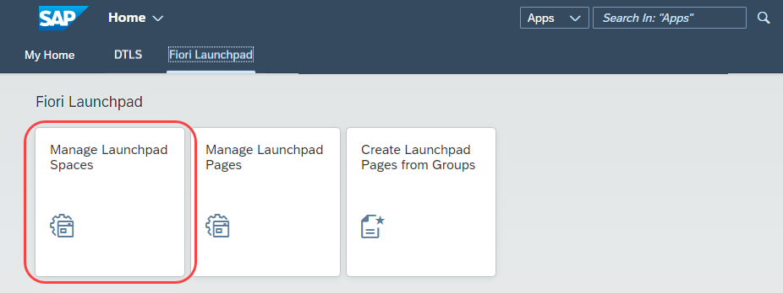
- Then choose the ‘Create’ button:
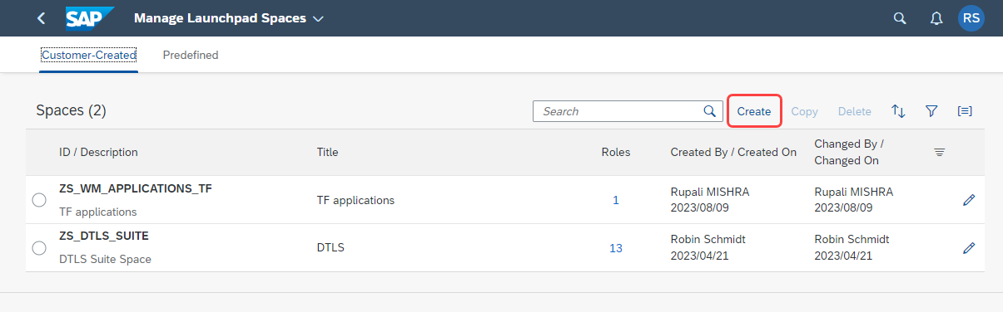
- In the ‘Create Space’ dialog enter the following:
- Space ID: ZS_DTLS_SUITE
- Space Description: DTLS Suite Space
- Space Title: DTLS
- Choose the ‘Also create a page’ checkbox.
- Page ID: ZP_DTLS_PAGE
- Page Description: DTLS Page
- Page Title: DTLS
And choose your Customizing transport created as a prerequisite for this section.
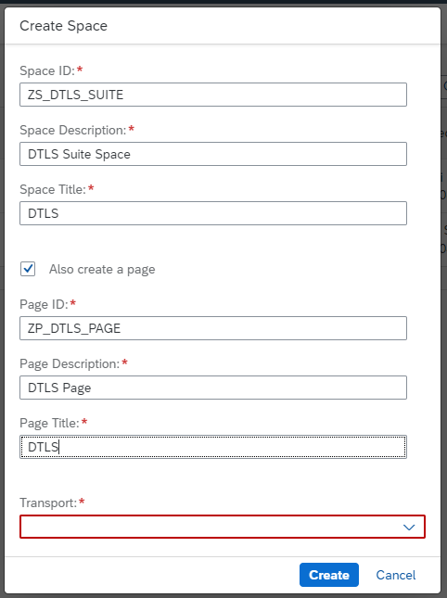

Configuring Custom Page
In this step, we will create the required Page Sections and add the Tiles from our Custom Catalog to the Page.
Use the following table as an example of how the Page Sections can be created and organized to display the DTLS applications:
Page Section Description | Lifecycle Management | Configuration | Material Management | Analytics and BI
Application
Process Builder | X
Process History | X
Relationship Explorer | X
Handover to Manufacturing | X
Facility Fit | X
Manage Equipment Classes |  | X
Manage Flavour Class (Group) |  | X
Manage Flavour Characteristic |  | X
Manage Types |  | X
Manage Material Master Data |  |  | X
Manage Material Classes |  |  | X
Manage Process Areas |  | X
Manage Risk Types |  | X
Manage Step Templates |  | X
Manage Operation Templates |  | X
Manage Process Workflow Rules |  | X
My Tasks | X
Thread Execution Analyzer |  |  |  | X
Site Model |  | X
Manage Reporting Layers |  | X
Products |  | X
Manage Capabilities |  | X
Manage Modalities |  | X

- Navigate to the ‘Manage Launchpad Pages’ app in the Fiori Launchpad:
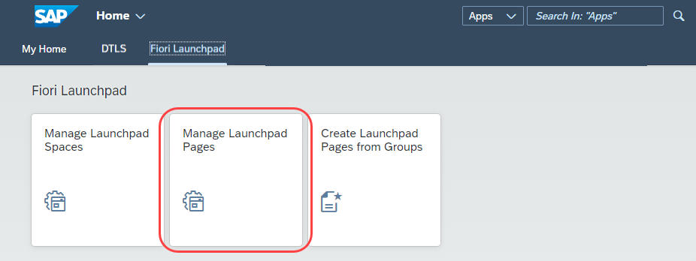

- Choose the ZP_DTLS_SUITE Page that was created in the previous step:
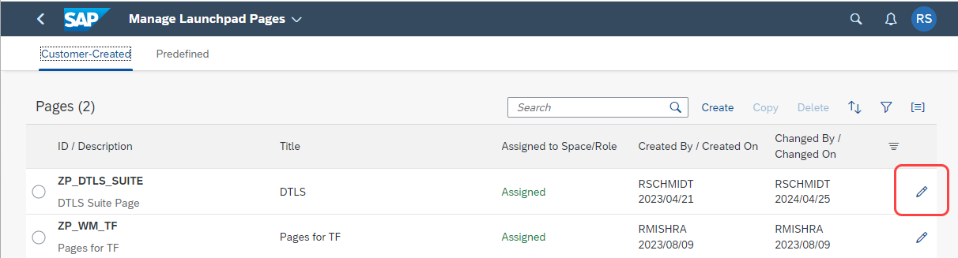
- Select the ZC_DTLS_Suite Catalog using the following dropdown/button:
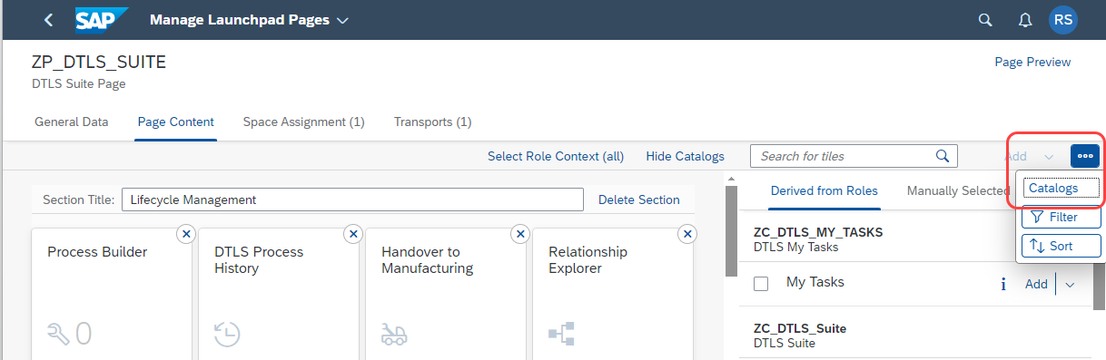
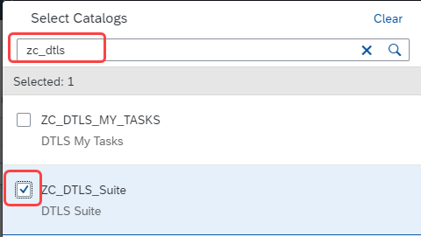

- Create the required sections as per the example table at the beginning of this section (or as per your requirements).
- Lifecycle Management
- Configuration
- Material Management
- Analytics and BI
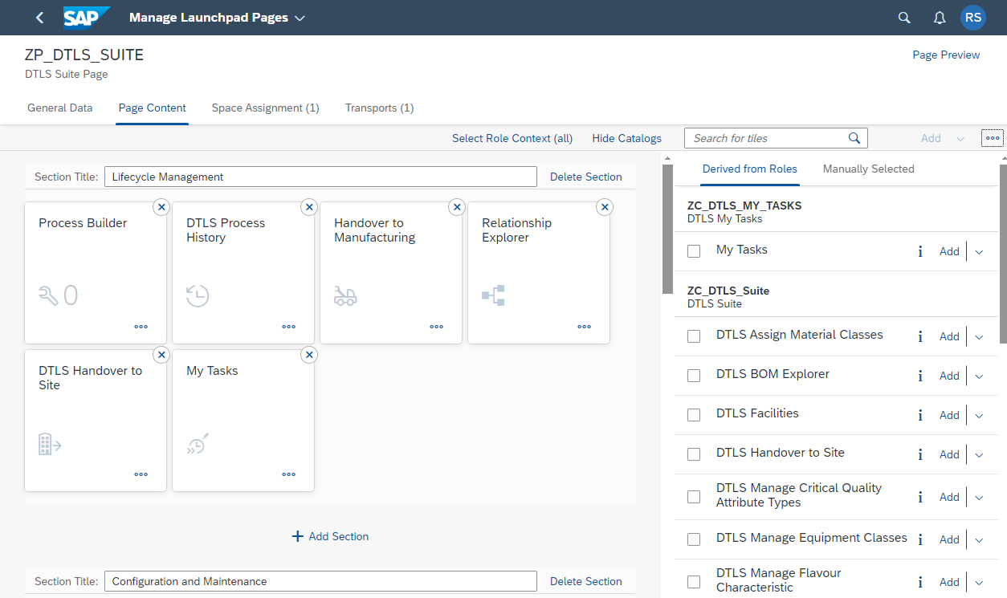
- After adding the required Applications to the Page Sections then ‘Save’ the Page.
NOTE: Space and Page Configuration is client-dependent so you may need to copy the configuration to any other related clients using transaction SCC1.

Security Role Configuration

Authorization Object: ZDTLS_S
- The main security auth object that controls access to DTLS applications is ZDTLS_S. This object will provide access to all applications.
  - The ZDTLS_AUTH field allows the customization of access for all DTLS applications.
  - The ACTVT field allows the restriction of activities within each DTLS application .
  - The ZDTLS_STGE field is currently not in use.
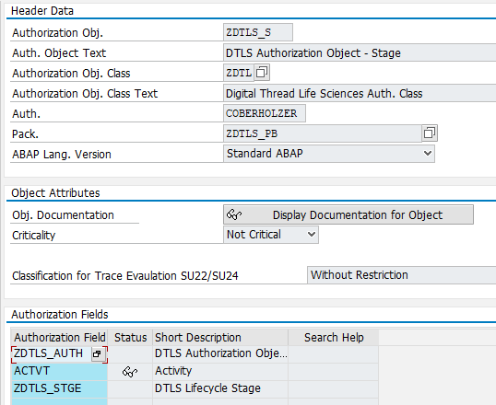

- The possible values for field ACTVT are as follows. These are selected based on what each assigned role needs to be able to complete. Multiple activities can be selected to customize the access of any given role.
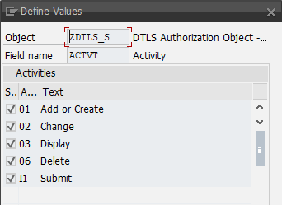
- The possible values for auth field ZDTLS_AUTH are as follows. Each authorization value corresponds to a DTLS application.
App Title | Auth Values
DTLS Assign Material Classes | DTLS_ASMC
DTLS Configuration | DTLS_CFG
DTLS Manage Equipment Classes | DTLS_EQUI
DTLS Sites | DTLS_FCL
DTLS Manage Flavour Characteristic | DTLS_FLCH
DTLS Manage Flavour Class | DTLS_FLV
DTLS Process History | DTLS_HIST
DTLS Hand Over to Manufacturing | DTLS_HOTM
DTLS Handover to Site | DTLS_HOTS
DTLS Layers | DTLS_LY
DTLS Manage Material Classes | DTLS_MATC
DTLS Material Master Data | DTLS_MM
DTLS Manage Process Areas | DTLS_PA
DTLS Process Builder | DTLS_PB
DTLS Comments | DTLS_PBCM
DTLS Manage Types | DTLS_PP
DTLS Product | DTLS_PRD
DTLS Modalities | DTLS_PRF
DTLS Relationship Explorer | DTLS_REL
DTLS Risk Type | DTLS_RSTY
DTLS Step Templates | DTLS_STPT
DTLS Thread Execution Analyzer | DTLS_TEA
DTLS Manage Process Workflow Rules | DTLS_WF

- This authorization field ZDTLS_STGE is currently not in use, it can be set to ‘*’ for Full Authorizations.

Creating DTLS Roles
The below composite and 5 single baseline roles will get users started in the system, however, they can be customized to cater to any system requirements:
- A composite Fiori Baseline role is required to access the DTLS Suite.
  - DTLS Fiori End User Role: this role contains the DTLS suite Fiori Group/Space and Catalog with all DTLS applications. This role should not contain the authorization object ZDTLS_S. This role must be assigned to all DTLS end users.
  - Copy and generate SAP Role SAP_UI2_USER_700 (Baseline Fiori Access)
  - Copy and generate SAP Role SAP_UI2_USER_750 (Baseline Fiori Access)
- Maintain Role: this role will allow create and change access within all DTLS applications.
- Display Role: this role will allow display access within all DTLS applications.

Creating a DTLS Fiori End User Role
NOTE: After adding the Fiori Catalog additional authorization objects will automatically be included in the role. It’s for this reason that the Fiori content should be created first and then added to the role. Then these additional authorization objects can be maintained in the following step as well.
These are the steps to create a new role that has all of the DTLS Catalog, Space, and Groups assigned to it. This role is required for any users that need access to DTLS applications.
- In transaction PFCG, a maintain role is created as shown below (please use role names as per your SAP Security naming conventions):
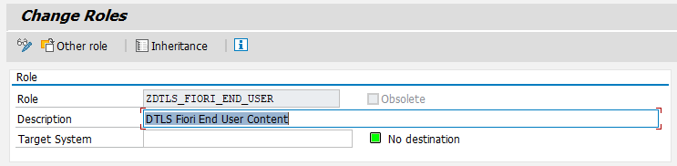

- In the Menu tab, add the following nodes via the dropdown:
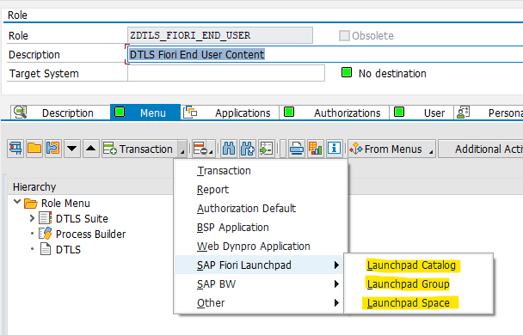
These are the details of each node as they are outlined in this guide; however, object names will vary as they are customizable and can follow other naming conventions:
Node Details: Space
Note: Spaces may or may not be in use at your company so may not be required.
- Type: Launchpad Space
- Object: ZS_DTLS_SUITE
- Text: DTLS
Node Details: Group
Note: If Spaces are being used then adding a Group is not necessary.
- Type: Launchpad Group
- Object: ZG_DTLS_Applications
- Text: Process Builder
Node Details: Catalog
- Type: Launchpad Catalog
- Object: ZC_DTLS_Suite
- Text: DTLS Suite
- Once the Fiori Catalog, Space, and Group are added, navigate to the Authorization tab to maintain authorizations for them. 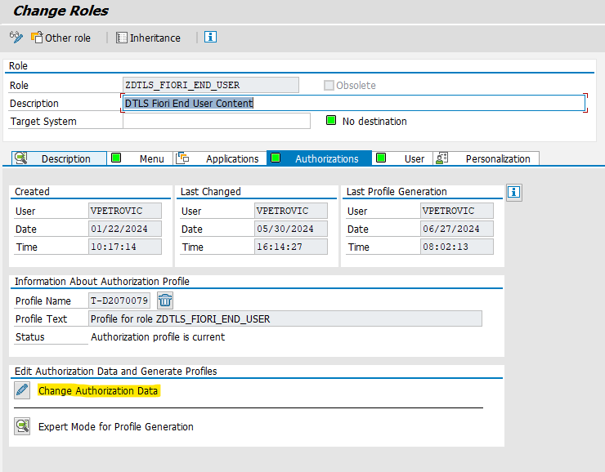
- A pop up for Organizational Levels might show up, based on business requirements, maintain the correct Org. Level values.
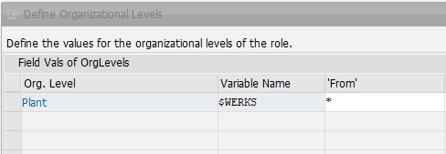

- For this role, maintain any pulled in authorization objects as ‘03’ display only.
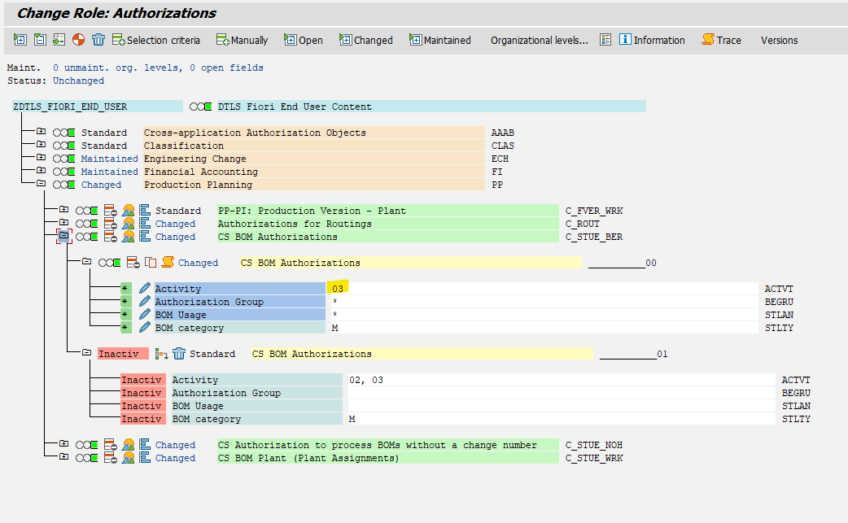
Manually Adding PDF Printing Authentication Object
- An additional authorization object must be manually inserted in order to facilitate PDF form printing. In the Authorizations tab, click the Change Authorization Data button to add the authorization object “S_BDS_DS”.
- On the next screen, click “Manually” to add the Authorization object required for PDF form printing. Type “S_BDS_DS” in the first field on the pop-up that appears.
- Once added, maintain the values as shown below, then, save and generate the role.
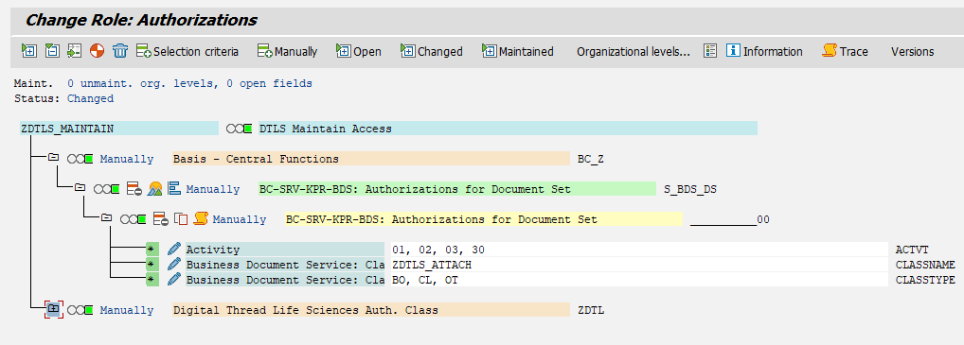
- Once all required maintenance is complete, save and generate the role.
Manually Adding Required DTLS Services

The following is a comprehensive list of services that might need to be manually added to the DTLS Fiori End User Role to mitigate any errors within the application.
The following should be manually added under the “S_SERVICE” Authorization Object as a TADIR Service:
Technical Name | Prog. ID | Obj. Type | Object Name*
D42D2D24B76A3091AA91B9B79822C1 | R3TR | IWSG | ZDTLS_CFG_UI_V2 0001
D42D2D24B76A3091AA91B9B79822C1 | R3TR | IWSV | ZDTLS_CFG_UI_V2 0001
012AD325C605BD87345C275C643E8D | R3TR | IWSG | ZODATA_DIGITAL_SIGNATURE_SRV_0001
199DB8557A89BEF3B6A046ECC8649F | R3TR | IWSV | ZDTLS_UI_OPTEMPLATES_V2 0001
258DF9E4269B3F208B41D1E685E238 | R3TR | IWSG | ZDTLS_GET_PROC_PARAMETER_0001
2C5175F16DE6F52BC2A5C354EB4990 | R3TR | IWSG | ZDTLS_GET_PB_LYR_VERS_STAT_0001
311BE9891EE1EF640E66F4DDBE0A80 | R3TR | IWSG | ZDTLS_GET_TIMELINE_OBJ_REC_0001
322C8244E074C69202F8DBAE6362D9 | R3TR | IWSG | ZDTLS_FCL_EQVER_UI_V2_0001
3277E328F13101054E47559669B136 | R3TR | IWSV | ZDTLS_GET_PB_LYR_CHG_FLDEX 0001
34EF8E74013A27ECFDD7624E623887 | R3TR | IWSV | ZI_DTLS_WF_LAYER_APPROVERS_CDS 0001
3AE0F596EBE1843EC6B22737ED90F6 | R3TR | IWSG | ZTASKPROCESSING_0002
5806EF160D74F2FC8FBBA14EB2B146 | R3TR | IWSV | ZDTLS_GET_TIMELINE_OBJ_REC 0001
68A3692CF12AB4DD55699FAB73BBAD | R3TR | IWSV | ZDTLS_UI_STEPTEMPLATES_V2 0001
70640ADBC0D3D0BB067FEABB5B5A67 | R3TR | IWSV | ODATA_DIGITAL_SIGNATURE_SRV 0001
7C854410203CAF03810248F7774074 | R3TR | IWSV | ZDTLS_GET_WF_STATUS 0001
833A2B24E533114C791D2EE42BBE86 | R3TR | IWSG | ZDTLS_GET_PB_LYR_CHG_I_UOM_0001
872AD38A493D8E36C34087B9F3BC3E | R3TR | IWSV | ZDTLS_GET_TIMELN_METADATA 0001
8F438FF4231AA32CF7413234003EBC | R3TR | IWSV | /IWPGW/TASKPROCESSING 0002
8FF1664448A31E955947E76B004592 | R3TR | IWSG | ZI_DTLS_WF_LAYER_APPROVERS_CDS_0001
94E3DF589527A60FDB377977493AEC | R3TR | IWSV | ZDTLS_GET_DIG_SIGNATURE 0001
A33573E28333197E3B9CC90EE1D978 | R3TR | IWSV | ZDTLS_GET_PB_LYR_CHG_I_UOM 0001
A5F58B2BECA104C951D032FD26ED3A | R3TR | IWSG | ZDTLS_UI_STEPTEMPLATES_V2_0001
B04F33294548207B7A127A7A0FA7B9 | R3TR | IWSV | ZDTLS_GET_PB_LYR_VERS_STAT 0001
B909DDD6C420F2AB80711256B4F528 | R3TR | IWSG | ZDTLS_GET_DIG_SIGNATURE_0001
BFC410F7DB0660ECFF61F6878A246B | R3TR | IWSV | ZDTLS_GET_PROC_PARAMETER 0001
C37747678073D12E591C7501619A82 | R3TR | IWSG | ZDTLS_UI_OPTEMPLATES_V2_0001
C515EB2E7AC8CA332F303CD4F02289 | R3TR | IWSG | ZDTLS_GET_WF_STATUS_0001
DA1AE5942569AD8D956884BFE19BBA | R3TR | IWSV | ZDTLS_WF_SRV 0001
DCCAE84C0E9ECA5CDD8F917B1AD982 | R3TR | IWSG | ZDTLS_WF_SRV_0001
DF382A784BB60891319F9A2CD9401D | R3TR | IWSV | ZDTLS_PB_GW_SRV 0001
E19E463E0CD30E60843A15DB7311E6 | R3TR | IWSG | ZDTLS_GET_TIMELN_METADATA_0001
E3BAEFAAA0FCADE815F7A001388853 | R3TR | IWSG | ZDTLS_GET_PB_LYR_CHG_FLDEX_0001
A1F7B981CD0DB101FEB1095E86A588 | R3TR | IWSG | ZDTLS_ADD_SRV_0001
1D8F754AD40DB56AA9A9A5300B4584 | R3TR | IWSV | ZDTLS_ADD_SRV 0001
B1BC53F12F68CCB0E41C23BFC5C99A | R3TR | IWSG | ZDTLS_FACILITY_FIT_SRV_0001
DBCC7CB8C906D9A7206946BF13EB93 | R3TR | IWSV | ZDTLS_FACILITY_FIT_SRV 0001

*The spaces between characters in the “Object Name” column are necessary
The following should be manually added under the “S_START” Authorization Object as an “SAP Gateway OData V4 Backend Service Group and Assignment”:
Technical Name | Prog. ID | Obj. Type
ZDTLS_UI_CAPABILITIES_V4 | R3TR | G4BA
ZDTLS_SITES_UI_V4 | R3TR | G4BA
ZDTLS_UI_PRODUCT_V4 | R3TR | G4BA
ZDTLS_UI_REPORTLAYERS_V4 | R3TR | G4BA
ZDTLS_UI_STEPTEMPLATES_V4 | R3TR | G4BA
ZUI_DTLS_TPT_STEP_ODATA_V4 | R3TR | G4BA
ZDTLS_UI_OPTEMPLATES_V4 | R3TR | G4BA
ZDTLS_CFG_UI_V4 | R3TR | G4BA
ZDTLS_TW_EQUIPMENT_CLASS_API | R3TR | G4BA
ZDTLS_TW_PROCESS_API | R3TR | G4BA
ZDTLS_TW_PROCESS_AREA_API | R3TR | G4BA
ZDTLS_TW_PRODUCT_API | R3TR | G4BA
ZDTLS_TW_SITE_API | R3TR | G4BA
ZDTLS_TW_STEP_TEMPLATE_API | R3TR | G4BA
ZDTLS_TW_PARAMETER_TYPE_API | R3TR | G4BA
ZDTLS_TW_LAYER_API | R3TR | G4BA

Manually Adding Catalog for Notifications
The following catalog must be maintained in the DTLS Fiori End User role to allow the receiving of notifications within DTLS:
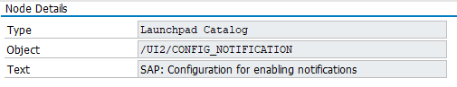
Manually Adding Authorization for Work Flow
The following security authorization for authorization object “S_WF_WI” needs to be configured to facilitate Work Flow Item Handling:
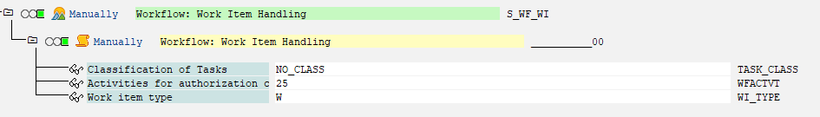
Manually Adding Authorization for Digital Signatures
The following security authorization for authorization objects “C_SIGN” and “C_SIGN_BGR” needs to be maintained if Digital Signatures are active in the system:

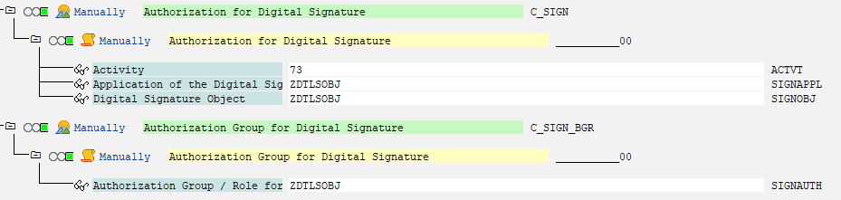

Creating a DTLS Maintain Role
These are the steps to create a new role that has create and change privileges throughout the DTLS landscape.
*Please note, there is an assumption that end users already have the required Fiori baseline access.
- In transaction PFCG, a maintain role is created as shown below (please use role names as per your SAP Security naming conventions):
- This role will only contain the authorizations for maintain access to DTLS applications, it will not have any Menu entries as the menu is built from the DTLS Fiori All User role.
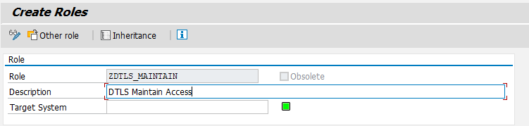
- Manually add the DTLS Authorization Object ZDTLS_S.
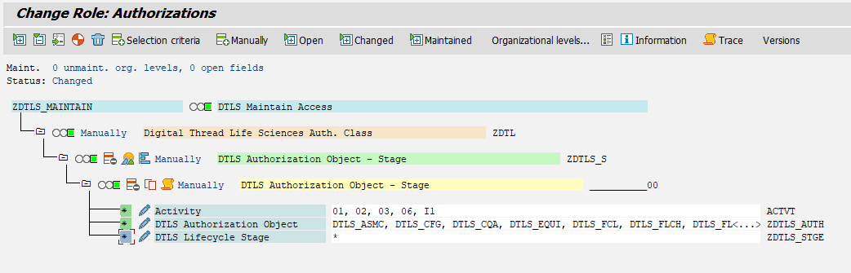
- The current possible values for the ZDTLS_AUTH field are shown below. They can be customized based on business requirements.
  - Please note, this field should not be maintained with a “*” value, ensure that each application that is desired is selected individually.
App Title | Auth Values
DTLS Assign Material Classes | DTLS_ASMC
DTLS Configuration | DTLS_CFG
DTLS Manage Process Quality Attribute Type | DTLS_CQA
DTLS Manage Equipment Classes | DTLS_EQUI
DTLS Sites | DTLS_FCL
DTLS Manage Flavour Characteristic | DTLS_FLCH
DTLS Manage Flavour Class | DTLS_FLV
DTLS Process History | DTLS_HIST
DTLS Hand Over to Manufacturing | DTLS_HOTM
DTLS Handover to Site | DTLS_HOTS
DTLS Layers | DTLS_LY
DTLS Manage Material Classes | DTLS_MATC
DTLS Material Master Data | DTLS_MM
DTLS Manage Process Areas | DTLS_PA
DTLS Process Builder | DTLS_PB
DTLS Comments | DTLS_PBCM
DTLS Manage Types | DTLS_PP
DTLS Product | DTLS_PRD
DTLS Product Family | DTLS_PRF
DTLS Relationship Explorer | DTLS_REL
DTLS Risk Type | DTLS_RSTY
DTLS Step Templates | DTLS_STPT
DTLS Thread Execution Analyzer | DTLS_TEA
DTLS Manage Process Workflow Rules | DTLS_WF

- For the Maintain role, the following activities can be maintained:
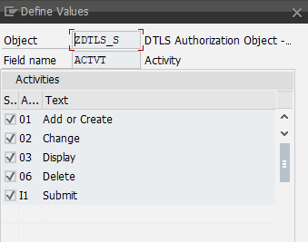

Adding S_TABU_NAM Value for Workflow Display/Edit
The following value is needed in the DTLS Maintain Role in order to facilitate display and edit access for Process Builder Workflow
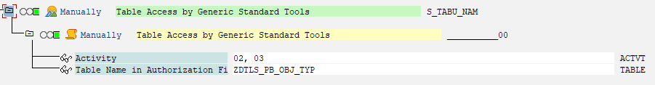

**For Future Development**
The ZDTLS_STGE field values are as follows. They are also all selected for this Maintain role.
Note: The stage “None” is also a change and is different from selecting no values for this auth field. A process without a selected stage would be considered “None”, which should be selected as needed.
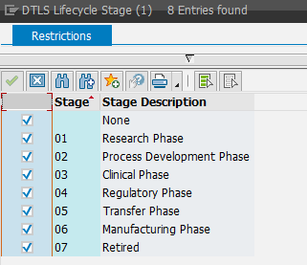

Creating a DTLS Display Role
These are the steps to create a new role that has display privileges throughout the DTLS landscape.
*Please note, there is an assumption that end users already have the required Fiori baseline access.
- In transaction PFCG, a display role is created as shown below (please use role names as per your SAP Security naming conventions):
- This role will only contain the authorizations for display access to DTLS applications, it will not have any Menu entries as the menu is built from the DTLS Fiori All User role.
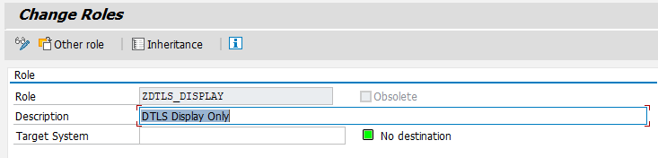
- Manually add the DTLS Authorization Object ZDTLS_S
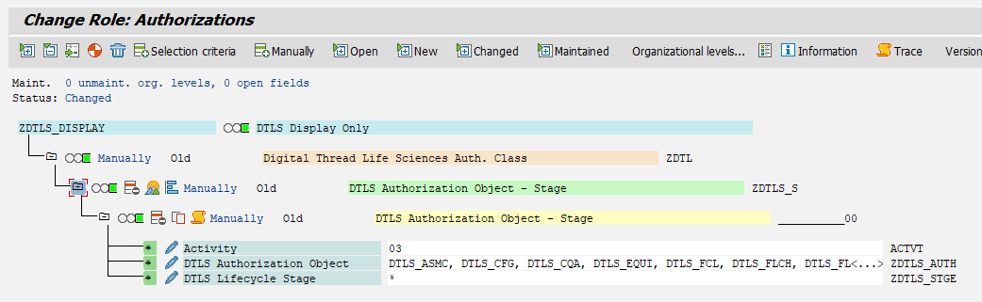
- The activities are selected based on what access is required. For the “Display” role being created, the checked activity below can be selected.
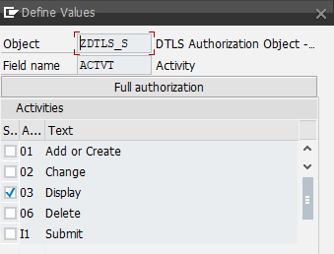
- The DTLS Authorization Object values are included and can be customized depending on predetermined conditions. For this “Display” role. All the remaining authorization object values can be selected based on business requirements.

App Title | Auth Values
DTLS Assign Material Classes | DTLS_ASMC
DTLS Configuration | DTLS_CFG
DTLS Manage Process Quality Attribute Type | DTLS_CQA
DTLS Manage Equipment Classes | DTLS_EQUI
DTLS Facilities | DTLS_FCL
DTLS Manage Flavour Characteristic | DTLS_FLCH
DTLS Manage Flavour Class | DTLS_FLV
DTLS Process History | DTLS_HIST
DTLS Hand Over to Manufacturing | DTLS_HOTM
DTLS Handover to Site | DTLS_HOTS
DTLS Hold Times Type | DTLS_HT
DTLS Manage Intermediate Quality Attribute Type | DTLS_IQA
DTLS Layers | DTLS_LY
DTLS Manage Material Classes | DTLS_MATC
DTLS Material Master Data | DTLS_MM
DTLS Manage Process Areas | DTLS_PA
DTLS Process Builder | DTLS_PB
DTLS Comments | DTLS_PBCM
DTLS Manage Process Parameter Type | DTLS_PP
DTLS Product | DTLS_PRD
DTLS Product Family | DTLS_PRF
DTLS Relationship Explorer | DTLS_REL
DTLS Risk Type | DTLS_RSTY
DTLS Sample Plans | DTLS_SP
DTLS Step Templates | DTLS_STPT
DTLS Thread Execution Analyzer | DTLS_TEA
DTLS Manage Process Workflow Rules | DTLS_WF

**For Future Development**
The DTLS Lifecycle Stage object values are as follows. They are also all selected for this “Display” role.
Note: The stage “None” is also a change and is different from selecting no values for this auth field. A process without a selected stage would be considered “None”, which should be selected as needed.

- Once everything is assigned, save and generate the role.

3.2.3.1 Adding Comment Functionality to a Display User
In order to activate the comment functionality in DTLS for a display user, the following values need to be manually maintained either in a separate role, or in a DTLS display only role.
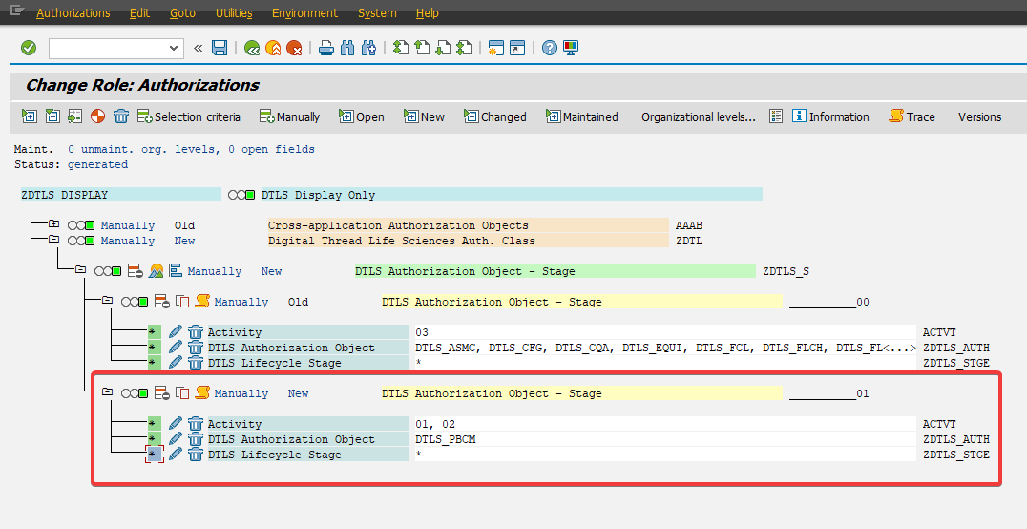
Without the DTLS_PBCM value maintained, comments will not be editable in the system.

Workflow Functionality
If Workflow functionality is in scope, the following roles are required.

Workflow Configuration Role
The purpose of the Workflow Admin role is to provide access to the DTLS Manage Process Workflow Rules app. This app is used to configure the workflow rules for all DTLS objects.
Role Requirements:
- Fiori Catalog assigned that contains the DTLS Manage Process Workflow Rules app
- Fiori Space that contains the DTLS Manage Process Workflow Rules app
- In the auth object ZDTLS_S, populate the ZDTLS_AUTH field with the ZDTLS_WF value and the ACTVT field with 01, 02, and 03
Please see below sections 3.4.2 and 3.4.3 as the roles defined in those sections are required for workflow configuration.

Workflow Notification Role
This role is used in the Workflow Rule configuration and is used to determine the Users who will receive an email notification when a DTLS object is submitted for Approval.
The role does not require any specific authorizations to be added, it only needs to have the users assigned who should get the Notifications.
The technical role name needs to be added during Rule Creation in the ‘DTLS Manage Process Workflow Rules’ application.
The technical name of the role needs to be provided to the resource that is performing the workflow configuration tasks. Also, this role is to be assigned to end users that should receive workflow notifications.

Workflow Approver Role
This role is used in the Workflow Rule configuration and is used to determine the Users who will receive Workflow Approval requests when a DTLS object is submitted for Approval. These users will receive an email notification and will be able to see their Workflow Tasks in the Fiori My Tasks application. See “DTLS Functional Guide: Workflow Approval” for more information on Workflow and the My Tasks application.¹
The role does not require any specific authorizations to be added, it only needs to have the users assigned who will be required to approve submitted DTLS Object creations or changes.
The technical role name needs to be provided to the resource that is performing the workflow configuration tasks to be added during Rule Creation in the ‘DTLS Manage Process Workflow Rules’ application.
If digital signatures are being used, the following authorizations should be added to this role.
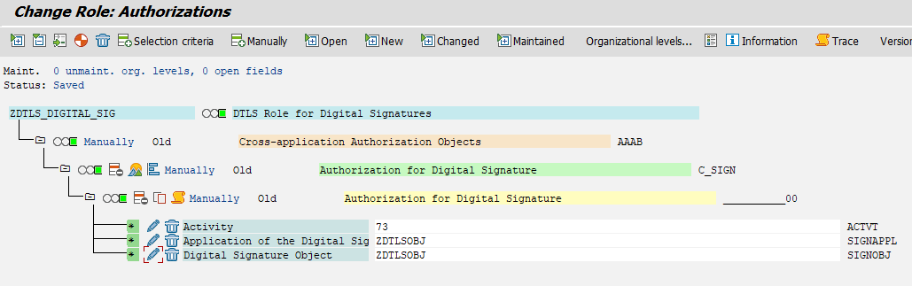
- Auth Object: C_SIGN
  - ACTVT = 73
  - SIGNAPPL = ZDTLSOBJ
  - SIGNOBJ = ZDTLSOBJ

Advanced Configuration
The following matrix outlines advanced configuration that can be followed if more granular per app security is required. First, an example of how to read the matrix is provided:
App Name: name of DTLS application
Auth Value in ZDTLS_AUTH: authorization value that controls access to specific applications
In order to use any of the applications listed in the App Name column, the corresponding ACTVT values need to be maintained for each listed Auth Value in ZDTLS_S.

 | Auth Value in ZDTLS_AUTH
 | DTLS_HIST | DTLS_REL | DTLS_PB | DTLS_HOTM | DTLS_MM | DTLS_  FLV | DTLS_  FLCH | DTLS_  EQUI | DTLS_WF | DTLS_PA | DTLS_PP | DTLS_  TEA | DTLS_  STPT | DTLS_MATC | DTLS_ASMC | DTLS_  FCL | DTLS_  LY | DTLS_PRD | DTLS_PBCM | DTLS_PRF | DTLS_CFG | DTLS_RSTY
App Name
DTLS Process History | 03 |  | 03 |  | 03 | 03 | 03 | 03 | 03 | 03 | 03 |  | 03 | 03 | 03 | 03 | 03 | 03 |  | 03
DTLS Relationship Explorer |  | 03
DTLS Process Builder |  |  | 01, 02, 03 |  | 03 | 03 | 03 | 03 | 03 | 03 | 03 |  | 03 | 03 | 03 | 03 | 03 | 03 | 01, 02 | 03
DTLS Handover to Manufacturing |  |  | 03 | 01, 02, 03
DTLS Material Master Data |  |  |  |  | 01, 02, 03
DTLS Manage Flavour Class |  |  |  |  |  | 01, 02, 03 | 03
DTLS Manage Flavour Characteristic |  |  |  |  |  |  | 01, 02, 03
DTLS Manage Equipment Classes |  |  |  |  |  |  |  | 01, 02, 03
DTLS Manage Process Workflow Rules |  |  |  |  |  |  |  | 03 | 01, 02, 03 | 03 | 03
DTLS My Tasks
DTLS Manage Process Areas |  |  |  |  |  |  |  |  |  | 01, 02, 03
DTLS Manage Process Quality Attribute Type
DTLS Manage Intermediate Quality Attribute Type
DTLS Manage Process Parameter Type |  |  |  |  |  |  |  |  |  |  | 01, 02, 03
DTLS Thread Execution Analyzer |  |  |  |  |  |  |  |  |  |  |  | 03
DTLS Step Templates/Operation Templates |  |  |  |  | 03 |  |  | 03 |  |  | 03 |  | 01, 02, 03 | 03 | 03 | 03 | 03 | 03 |  | 03
DTLS Manage Material Classes |  |  |  |  |  |  |  |  |  |  |  |  |  | 01, 02, 03
DTLS Assign Material Classes |  |  |  |  | 03 |  |  |  |  |  |  |  |  | 03 | 01, 02, 03
DTLS Hold Times Type
DTLS Sample Plans
DTLS Site Model |  |  |  |  | 03 |  |  | 03 |  |  | 03 |  | 03 | 03 |  | 01, 02, 03 |  |  |  |  |  | 03
DTLS Manage Reporting Layers |  |  |  |  |  |  |  | 03 | 03 | 03 | 03 |  |  |  |  |  | 01, 02, 03
DTLS Manage Products |  |  |  |  |  |  |  |  |  |  |  |  |  |  |  |  |  | 01, 02, 03 |  | 03
DTLS Manage Modalities |  |  |  |  |  |  |  |  |  |  |  |  |  |  |  |  |  |  |  | 01, 02, 03
DTLS Facility Fit
DTLS Manage Capabilities
DTLS Manage Configuration Rules |  |  |  |  |  |  |  |  |  |  |  |  |  |  |  |  |  |  |  |  | 01, 03
DTLS Risk Types |  |  |  |  |  |  |  |  |  |  |  |  |  |  |  |  |  |  |  |  |  | 01, 02, 03

Common Issues and Troubleshooting Steps

4.1 - PFCG Custom ZDTLS TADIR Service does not show up in PFCG
Custom DTLS TADIR services are required to be added using PFCG when initially setting up DTLS specific security roles. If there is an instance where one of these services does not show up in PFCG, the following instructions may be able to mitigate the issue:
- Execute transaction SU25, it will show a series of utilities. Select the bottom most option titled 'SU22 Registration of Applications'.
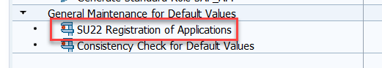
- Select the dropdown for “Type of Application”, then select “18. SAP Gateway: Service Groups Metadata”, untick the option “Exclude local applications”, and type *DTLS* in the object name field, as such:
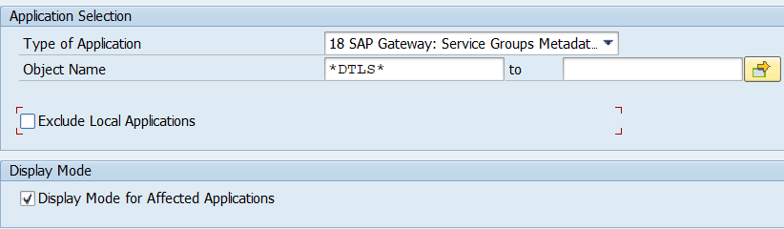
*Note: when executing the aforementioned step, run it with “Display Mode for Affected Applications” checked.
- Click the execute button. This will show all missing PFCG values that will be generated.
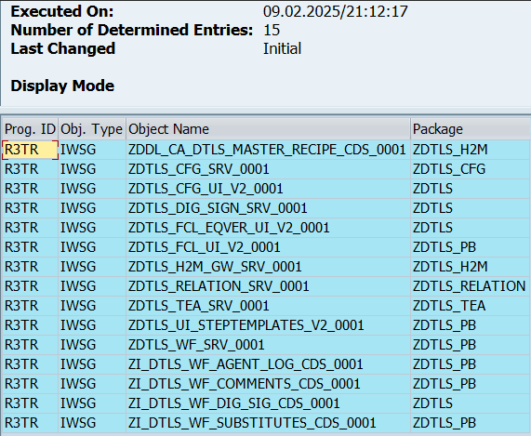
- After confirming the values that are needed, go back one screen and execute Step #3 again, this time with the “Display Mode for Affected Applications” box unchecked.
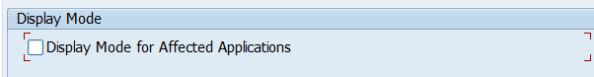
- Upon clicking execute once more with the display box unchecked, the utility will run and will register the missing services. There will be a small message indicating that the utility was successful:
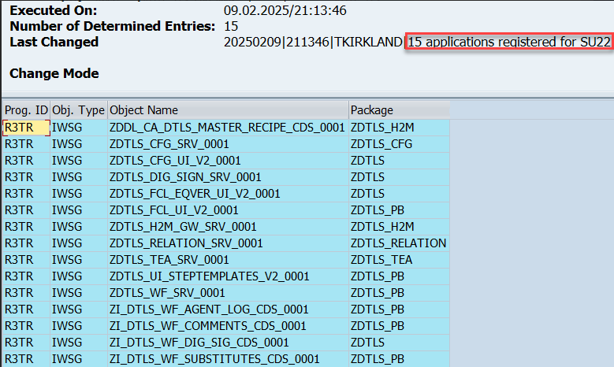
- Repeat steps 2-5 once more, this time selecting “19 - SAP Gateway Business Suite Enablement - Service” in the “Type of Application” dropdown
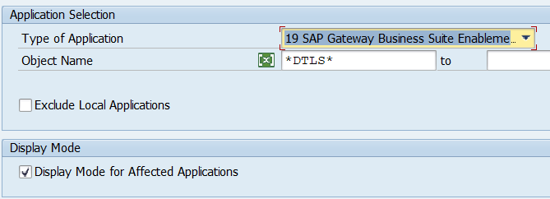
After executing these steps for both SAP Gateway: Service Groups Metadata and SAP Gateway Business Suite Enablement - Service, all missing authorizations should now be visible in PFCG for assignment to roles.

Document References
Reference No. | Document Title
1 | DTLS Functional Guide: Workflow Approval

Revision History
Version No. | Description | Date
4.1 | Initial document | 2024-04-20
4.2 | Updated to new package | 2024-06-24
4.4 | Updated to new package | 2025-01-28
5.1 | Updated to new package | 2025-05-14
FF | Updated to new package | 2026-01-30

